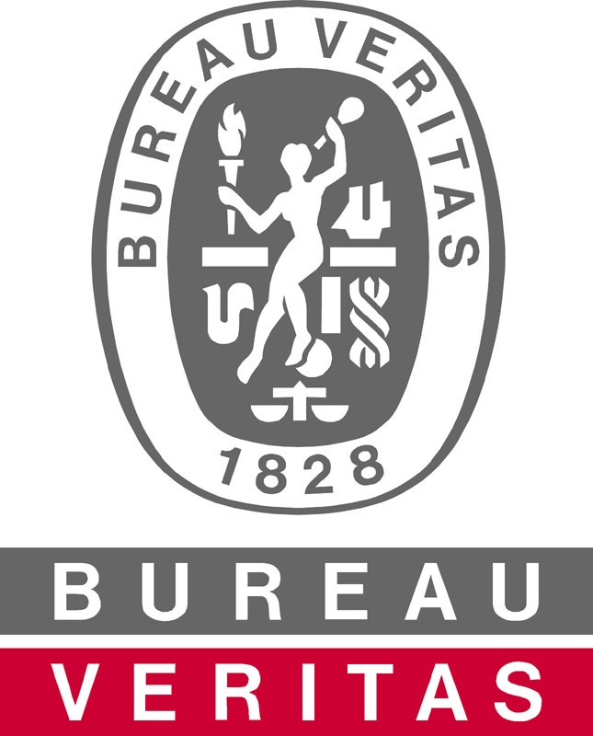

Bureau Veritas Certification

North America, Inc.

SFI Forest Management Audit Report
16800 Greenspoint Park Dr., Suite 300 S
Houston, TX 77060
Phone (281) 986-1300: Toll Free (800) 937-9311
Company Name |  |  | Catchmark Timber Trust
Contact Person |  |  | Childers Adams
Address |  |  | 5 Concourse Parkway, Suite 2325; Atlanta, GA 30328
Phone / Fax |  |  | Phone: (404) 445-8460 Fax: (855) 865-8223
PQC Code |  |  | E01E
Contract Number |  |  | US3698103
Certification  Audit: |  |  |  |  | Re-Certification Audit: | X |  | Surveillance Audit: |  |  | Scope extension audit:

Audit Summary
This report summarizes the results of the renewal audit conducted on Catchmark Timber Trust’s SFI program for forest management operations. Richard Boitnott, Bureau Veritas Certification Lead Auditor, conducted the audit May 5th through the 8th, 2020 in the South Central and Coastal management units. Mr. Boitnott is an SAF certified forester, a Texas accredited forester, and has wildlife management expertise. He worked for forest industry for 22 years in a variety of forestry and wildlife management positions.

Audit Scope, Objectives and Process
The scope of the audit is “management of forest lands”. It should be “management of forest lands in Georgia, Alabama, South Carolina, Florida and Oregon” The audit was conducted against the SFI 2015-2019 standard forest management edition. All applicable indicators within the forest management edition were covered during the audit. There was no substitution or modification of indicators. Specifically, two objectives of the SFI audit were to verify that the Program Participant’s SFI Program is in conformance with the SFI Objectives, Performance Measures, and Indicators, and any additional indicators that the Program Participant chooses, and verify whether the Program Participant has effectively implemented its SFI Standard program requirements on the ground. Standard Bureau Veritas Certification protocols and forms were applied throughout the audit as provided by the most recent version of the Bureau Veritas Certification SFI Auditor Handbook available on the auditor access website.

Audit Plan
The audit consisted of a review of program documentation at the Lumpkin Georgia office on Tuesday the 5th of May 2020. Field sites in the south-central management unit were reviewed Wednesday and Thursday May 6th and 7th, and in the Coastal management unit on the 8th. A closing meeting was held at the end of the day on the 8th. An audit plan was developed and is maintained on file by Bureau Veritas Certification.

Company Information
Catchmark Timber Trusts owns or manages approximately 409,000 acres of land in Georgia, Alabama, Florida, South Carolina, and Oregon. On-the-ground management is conducted by Forest Resource Consultants, Inc. (FRC) in Georgia, Alabama, and Florida, and by American Forest Management (AFM) in Oregon and South Carolina. This audit was limited to property the company manages out of Lumpkin Georgia and Waycross Georgia. Properties in these two areas consist primarily of loblolly pine uplands, with mixed pine-hardwood streamside management zones. Some true bottomland hardwood sites are also included in the ownership, and there are a few occurrences of longleaf pine on suitable sites. Topography varies from rolling to moderately steep in the Lumpkin area to flat and somewhat poorly drained to poorly drained in Waycross. The upland sites are regenerated artificially, using chemical site preparation and planting. Clearcut stands are also mechanically site prepared in the Waycross area. Hardwood types are regenerated naturally.

Multi-Site Requirements

Catchmark operates a multi-site certification program consisting of the four sites as shown below. All sites conduct the same activities; forest management. Catchmark operates a centrally-controlled management system, with one person responsible for oversight of the SFI program. An internal audit program is in place to ensure conformance of each site with the company’s SFI procedures.

Multi-Site | X | Group Certification

Sites | Sites Audited During this Event
Atlanta, GA HQ | X
GA/AL management unit | X
GA/FL management unit | X
Oregon management unit
SC/NC management unit
Audit Results
The document review was conducted to determine if Catchmark’s SFI program still meets the requirements of the SFI 2015-2019 Forest Management Standard. The field audit consisted of a review of eight harvest tracts, seven regeneration/chemical site preparation tracts, two mid-rotation release tracts, and one special area.

Objective 1-Forest Management Planning:

Catchmark continues to operate a forest management planning system that contains all the requirements of Objective 1. A stand-level inventory system remains in place. Volume is grown using the PMRC growth and yield model. 20% of all stands are cruised each year to validate the growth and yield model. The company uses Woodstock as its harvest modeling tool, including Stanley as the spacial component. The harvest schedule is run annually, taking into account removals, growth, and updated inventory information. A GIS is in place, which includes soil mapping. Biodiversity at landscape scales is documented through the company’s landscape assessment program found in Objective 4. Catchmark also tracks percentage of its ownership in various cover types and age classes. Consideration of non-timber issues has consisted of the inclusion of 135,000 acres of land in Georgia into a 15-year conservation agreement. Planned versus actual harvest levels demonstrate the company is generally harvesting in accordance with its sustainable harvest plan. Since 2016 the company has overcut its pine volume by 13% in the mid-atlantic region, and by 14% in the south- central region since 2014, primarily due to acquisitions, and the need to harvest soon-to-expire long-term leases. However, projected growth summary provides evidence the plan is sustainable. According to the plan, total inventory is projected to decrease slightly over the next several years in all southern regions, then increase slightly after the initial heavy harvest. The company is currently harvesting slightly more than growth. The company has only owned the Oregon property for two years, but projected harvest levels have been reduced considerably due to poor markets.

Catchmark practices conversion on a very limited basis. The only conversion that took place in 2019 was from a planted sweetgum plantation to loblolly pine. This was considered an ecologically beneficial conversion. The company has developed a review process for the few conversions it does conduct that meets the requirements of the standard.

Objective 2-Forest Health and Productivity:

Planting summaries provided evidence Catchmark is conducting artificial regeneration within two growing seasons after harvest, and natural regeneration within five. The company only had three acres that were regenerated more than two years after harvest is 2019.

Chemical applications continue to be well done in both management units. Rates were well below label maximums. The rates and types of chemicals used were typical for the types of competing vegetation in each region. Catchmark continues to do a very good job of keeping herbicide applications within the target area, with no drift into off-target areas observed during the audit. Soil maps are available. Soil productivity was very well protected, with no rutting or compaction observed during the audit. All employees were very well aware of the company’s rutting guidelines, and a review of harvest sites provided evidence the company is implementing its guidelines. Catchmark does a very good job of matching sites to weather conditions.

Objective 3-Protection and Maintenance of Water Resources:

Compliance with Georgia and Alabama BMPs was observed on all harvest and regeneration sites observed during the audit. Streamside management zones were well established on Catchmark property in both states, and road and skid trail construction and stabilization ensured protection of soil productivity and water quality. What few stream crossings installed were removed and approaches stabilized.

Objective 4-Conservation of Biological Diversity:

Catchmark has identified potential T&E species and FECVs that could occur across its ownership. The company has identified two significant species of concern that could be impacted by its operations in Georgia and developed management guidelines to protect these species where they are known to occur. The company has improved its system for gathering information in South Carolina in response to a non-conformance issued during surveillance three. Catchmark has also gathered information on T&E species, FECVs, and species of concern from the Oregon Biodiversity Information Center (ORBIC) and incorporated this information into the GIS managed by AFM. These species are also reviewed by the Oregon Department of Forestry during the Forest Practices Act notification process.

The company continues to make a good attempt to provide both dispersed and clumped retention in its clearcut areas, and to avoid spraying those trees during chemical site prep. Catchmark continues to utilize its landscape assessment program to monitor forest cover type and age classes on larger blocks of property.

Objective 5-Management of Visual Quality and Recreational Benefits:

The company’s reported average clearcut size for 2018 was 72 acres, with no region going above 120. The method for calculating clearcut size is documented.

There was little need for specific aesthetic considerations on any harvest sites in any region reviewed during the audit, as all were in relatively remote areas, offering little exposure to the public. Compliance with the company’s green-up was observed on all clearcuts.

Objective 6-Protection of Special Sites:

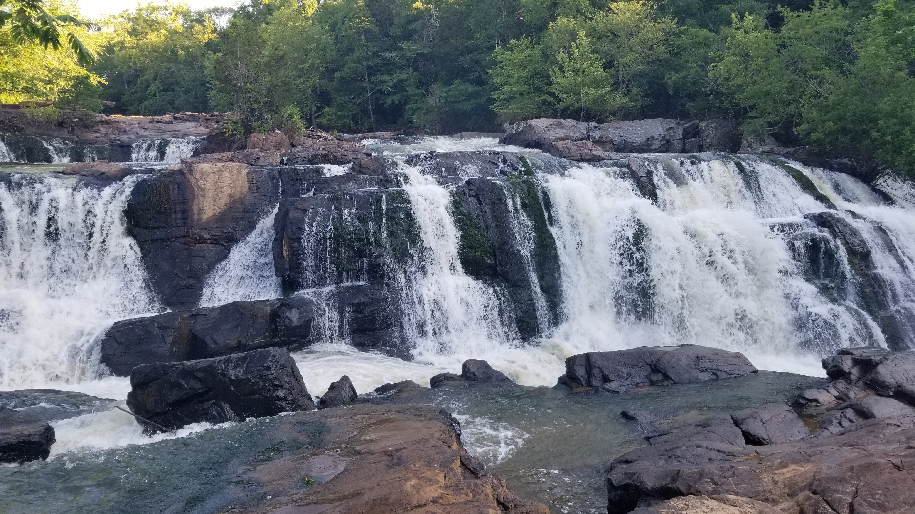
Mulberry Falls. One of the special areas managed by Catchmark

Special sites have been identified on Catchmark property. Management plans are in place for all designated special sites. One special area was reviewed during this audit. Mulberry Falls is unique for this part of Georgia. While no special management actions are necessary, recognition and protection are important.

Objective 7-Efficient Use of Fiber Resources:

Utilization was acceptable on all harvest units observed during the audit.

Objective 8: Recognize and Respect Indigenous People’s Rights:

Catchmark has a documented policy to respect the rights of indigenous peoples. There are no known rights or claims of any indigenous peoples on Catchmark property. The company has a process to respond to public inquiries, including those that may come from any concerns expressed by indigenous peoples. The only interaction with indigenous peoples occurs in Oregon. Local tribes are allowed to provide input on notifications, but seldom do so.

Objective 9-Legal and Regulatory Compliance:

Catchmark has access to applicable regulatory requirements. Its system to achieve compliance consists of a pre-harvest prescription process that identifies water quality requirements, and possible locations of T&E species. Contract language is in place to require compliance. Monitoring is conducted to further ensure compliance. One BMP inspection report has been conducted in Georgia, with excellent results. There was no evidence of regulatory actions taken against Catchmark activities.

Objective 10-Forestry Research, Science and Technology:

The company demonstrated evidence it is involved in research efforts applicable to its landbase. Much of its financial contributions are towards forest productivity, but the company also cooperates in Mississippi Kite, Fringed campion, and Indigo snake surveys. Contributions are documented in management review meeting minutes. Its membership in the SICs in all the states in which it operates includes the development of biodiversity conservation information for family forest landowners. The company also gathers information on BMP implementation in the states in which it operates. Catchmark has access to information on the potential impacts of climate change on forest health and wildlife habitat.

Objective 11-Training and Education:

Catchmark has a training program in place. Training records verified employees have received training as required by the company’s training matrix. Catchmark requires all contractors to have at least one person on-site who has completed SIC sponsored logger training. This requirement is a part of the logging contract. The logger training programs in the states in which Catchmark operates have continuing education requirements.

Objective 12-Community Involvement and Landowner Outreach:

Catchmark is a member of the SICs in all the states in which it operates, with the exception of Florida, where its footprint is very small. The company has joined the Oregon SIC after completing its purchase of this property two years ago. Membership in the SICs includes the distribution of landowner education materials, which contains information on the conservation of biological diversity. Catchmark demonstrated involvement in a number of public educational activities, particularly in promoting forestry to school children and in supporting log-a-load for kids. It has a process to respond to public inquiries or complaints. The company has received no reports of inconsistent practices.

Objective 13: Public Land Management Responsibilities: N/A-Catchmark does not have public land management responsibilities.

Objective 14-Communications and Public Reporting:

The company had posted its 2019 surveillance audit report on the SFI, Inc. website as required for public review. The 2019 SFI annual progress report had been submitted in a timely manner.

Objective 15-Management Review: Catchmark has a management review process in place. The company has historically done a good job of recording meeting minutes and continues to do so. Management review minutes verified the meeting is held annually as required by the SFI Standard.

Findings

Previous non-conformances:
No non-conformances were issued during the previous audit.

Non-conformances:
No non-conformances were issued during this audit.

Opportunities for Improvement:
No opportunities for improvement were issued.

Notable Practices:
No notable practices were issued.

Logo/label use:
Catchmark uses the SFI logo on its website for promotional purposes. Approval is documented. The company does not use the BVC logo.

SFI reporting:
The 2019 surveillance audit report was found on the SFI website as required for public review.

Review of Previous Audit Cycle
Catchmark received a non-conformance during surveillance three due to an inadequacy in its program to identify and protect FECVs and significant species of concern on its property in South Carolina. The corrective actions put in place for this non-conformance remain effectively implemented. No other non-conformances were issued during the previous audit cycle, and all opportunities for improvement have historically been well addressed.

Conclusions

Since no non-conformances were issued, Catchmark is recommended for renewed certification to SFIS 2015-2019 Forest Management Edition effective immediately.

SEE SF61 for Audit Notes

Summary of Audit Findings:
Audit Date(s): |  |  | From: May 5, 2020 |  |  |  |  |  |  |  |  |  |  |  |  |  |  |  |  | To: May 8, 2020
Number of SF02’s Raised: |  |  |  |  |  |  |  |  |  |  |  | Major: |  |  |  |  |  | 0 |  |  |  |  | Minor: |  |  |  | 0
Is a follow up visit required: |  |  |  |  |  | Yes |  |  |  |  |  | No |  | X |  |  | Date(s) of follow up visit:
Follow-up visit remarks:
Team Leader Recommendation:
Corrective Action Plan(s) Accepted |  |  |  |  |  |  | Yes |  |  |  |  |  | No |  |  |  |  |  | N/A |  | X |  |  | Date:
Proceed to/Continue Certification |  |  |  |  |  |  | Yes |  |  |  | X |  | No |  |  |  |  |  | N/A |  |  |  |  | Date: | 5/8/2020
All NCR’s Closed |  |  |  |  |  |  | Yes |  |  |  |  |  | No |  |  |  |  |  | N/A |  | X |  |  | Date:
Standard audit conducted against:
1) | SFI 2015-2019 FM Standard |  |  |  |  |  | 3)
2) |  |  |  |  |  |  | 4)
Team Leader (1): |  |  |  |  | Team Members (2,3,4…)
Richard Boitnott; CF, TX AF |  |  |  |  | 2)
 |  |  |  |  | 3)
 |  |  |  |  | 4)
 |  |  |  |  | 5)
Scope of Supply: (scope statement must be verified and appear in the space below)
Management of forest lands

Accreditation's |  |  |  | ANAB
Number of Certificates |  |  |  | 1

Proposed Date for Next Audit Event
Date |  | March 22-26, 2021

Audit Report Distribution
Bureau Veritas Certification: Lorisa Love-lorisa.love@us.bureauveritas.com
Catchmark: Kathleen Ellis-kathleen.ellis@catchmark.com

Clause |  | Audit Report
Opening Meeting | Participants:  Discussions: | Childers Adams, Dusty Warren, Jonathan Kenney, Kathleen Ellis, Robin Finlayson  - Introductions  - Scope of the audit  - Audit schedule/plan  - Nonconformance types – Major / Minor  - Review of previous nonconformances - 0.  - Process approach to auditing and audit sampling  - Confidentiality agreement  - Termination of the audit  - Appeals process  - Closing meeting timing
Closing Meeting | Participants:  Discussions: | Childers Adams, Kathleen Ellis, Ike Vinson, Chris Faith, Ethan Brett  - Introductions and appreciation for selecting Bureau Veritas Certification.  - Review of audit process - process approach and sampling.  - Review of OFIs and System Strengths  - Nonconformances - 0  - Date for next audit.  - Reporting protocol and timing

